**Title of the Extended Abstract**

**Author1, Author2 and Author1,\***

1 Afflialation 1 ……………………………….…………

2 Afflialation 2 …………………………………………………..

**\* Corresponding author**

Contact name : Name of corresponding author

Telephone: +…………………………

E-mail: ………………………….

**Abstract**

The section must contain the summary of the four-pages extended abstract. It should give the overall view of the manuscript. A short description of the objective, methodology, and results and discussion. A short conclusion should be included too. This section should contain 300 words only.

**Keywords**:

(*Maximum of five keywords separated by ‘;’*)

**Introduction**

Give the introduction of the manuscript here. Include the objective(s) of the manuscript at the end of this section. Figures and Table can be inserted to elaborate the background of the manuscript. Separate the section into several paragraphs for ease of explanation.

**Methodology**

Briefly include the methodology used to complete the work. Simple diagrams can be included.

**Results and discussion**

The results and discussion of the manuscript should be elaborated here. Do not include any methodology in this section. Figures can be included and the format of the figure is illustrated in Figure 1.

Tables can also be included in this section. Template of a table can be seen in Table 1.

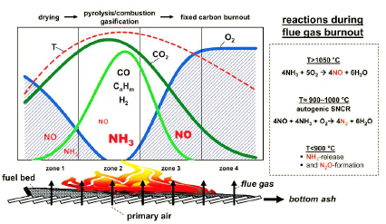

Figure 1 Label the figure immediately at the bottom of the figure.

All tables, plates and figures must be cited in the content of the manuscript before they appear in the manuscript. Number the figures, plates, and tables accordingly.

Table 1 Label the table above the table with brief description of the values in the table.

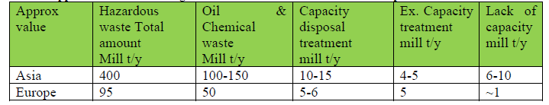

Include the discussion of the results in this section. Citation of other works must be accordingly acknowledged. The sample citation for a single author is (Li, 2018). For two authors, the citation is (Li and Huang, 2017), while for more than two authors, it should be (Smith et al., 2016). All references used must be listed in the reference list. Format of the references is shown in the references section, which must be arranged alphabetically.

**Conclusion**

Include the conclusion here. The maximum number of pages for this manuscript is four pages. The font for the main content of the manuscript is 12 Times New Roman, single – spacing and paragraphs are justified. The figures and tables must be centered.

**Acknowledgement**

Include all acknowledgements in this section.

**References**

Albanna, M., 2012. Solid Waste Management Options and their Impacts on Climate Change and Human Health. In: A. Malik and E. Grohmann, eds. Environmental Protection Strategies for Sustainable Development. Dordrecht: Springer Netherlands, pp. 499–528.

Awad, A. R., Obeidat, M., & Al-Shareef, M. (2004). Mathematical-Statistical Models of Generated Hazardous Hospital Solid Waste. *Journal of Environmental Science and Health*, Part A, 39(2): 315–327.

Komilis, D. P., Ham, R. K., & Stegmann, R. (1999). The effect of municipal solid waste pre-treatment on landfill behaviour: A literature review. *Waste Management and Research*, *17*, 10-19.

Ministry of the Environment Japan (2017): http://www.env.go.jp/press/104573.html (Accessed Sep.21.2017)

Regulation on classification, labelling and packaging of substances and mixtures, amending and repealing Directives 67/548/EEC and 1999/45/EC, and amending Regulation (EC) No 1907/2006